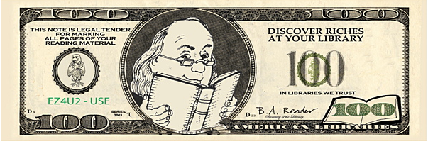
Mustang Mega Millionaires
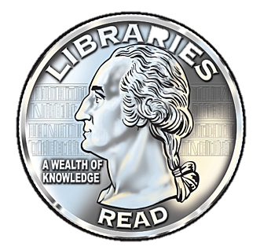
The following awards are given based on students independently reaching each word count goal, an 85% overall average, and reading in their book level.
These prizes will be awarded at the end of each 9 weeks.

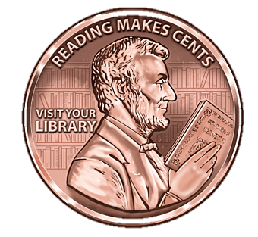
100,000 words – Cut Line Pass
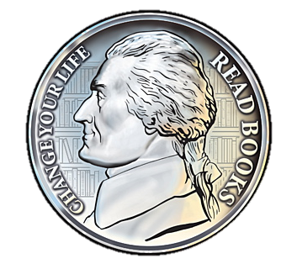
150,000 words – Spirit Key Ring
500,000 words – Coke & Cookie Party
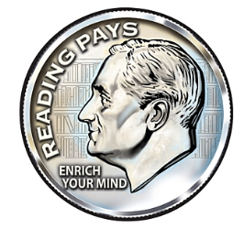
1,000,000 words – Ice Cream Party
2,000,000 words – Popcorn & Movie Party
3,000,000 words - Pizza Party
4,000,000 words – Librarian for a day
5,000,000 words – Principal for a day

End of the Year Millionaire Celebration
Million Word Recipients must have a 90% overall average, read independently within their reading zone, AND have at least 1,000,000 words documented within the AR Program by the cut-off date to participate in the End-of-Year Celebration.
Mega Million Readers
The student with the top word count in each grade at the end of the year will receive a $50.00 gift card to Barnes & Noble. They must have a 90% overall average, read independently within their reading zone, AND have more than 1,000,000 words documented within the AR Program by the cut-off date to qualify as a Mega Millionaire Reader.

